
Wayside
Health
Associates

Jay B. Krasner, MD, FACP

Internal Medicine and General Practice
111 Boston Post Road Suite 107
Sudbury, MA 01776
Phone: (978) 443-8010
Fax: (978) 443-4634
www.waysidehealth.com

Carbohydrate Food Pyramid
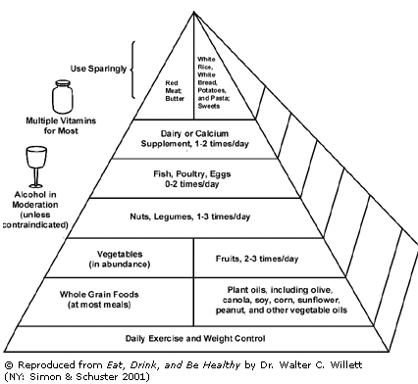

The Carbohydrate Food Pyramid is a little different than the USDA Food Guide Pyramid because it groups foods based on their carbohydrate and protein content instead of their classification as a food. For example: you will find potatoes in the starch group instead of the vegetables group. Not shown is the categorization of fruits and vegetables by their Glycemic Index:

 | Fruits | Vegetables
Best Choice  (low glycemic index)  Use freely | Cherries, Grapefruit, Plums | Asparagus, Broccoli, Celery, Cauliflower, Cucumber, Eggplant, Green beans, Lettuce, Mushrooms, Okra, Onions, Peppers, Snowpeas, Spinach, Summer squash, Zucchini
Better Choice  (moderate glycemic index) Use in moderation | Apples, Berries, Grapes, Melons, Nectarines, Peaches, Pears  All Unsweetened Fruit Juices | Popcorn, Tomatoes, Winter squash  All Vegetable Juices and Legumes (beans)
Good Choice)  (high glycemic index) Limit intake | Bananas, Kiwi, Mango, Papaya, Pineapple, Raisins, Watermelon  All Sweetened Fruit Juices, Canned Fruit and Dried Fruit | Carrots, Sweet Corn, Parsnips, Peas, Rutabaga, Sweet potatoes, Yams

